Management of chest wall tumors: 15 years clinical experience, a retrospective study of 52 patients

ABSTRACT

Introduction: Primary tumors of the chest wall are rare and have varied origins. The clinical manifestation is nonspecific, the main complaint is pain, but it is generally vague and fails to characterize a specific type or location, compromising early diagnosis.
Objective: Evaluation of patients with thoracic wall tumors submitted to surgical treatment in a tertiary hospital for oncological care.
Methods: Retrospective study of 52 cases, occurred between 1998 and 2013.
Results: There was a predominance of males, corresponding to 58% of the cases. The main histological types were lipoma, osteosarcoma, Schwanomma and immature teratoma. Out of the 52 cases, five were direct extension or metastasis from other sites that had the mass of the chest wall as their first manifestation of the disease. The main therapeutic modality was isolated surgery. The type of reconstruction used the most to close the surgical defect was the first intention closure, in 25 patients, followed by the myocutaneous flap in 22 patients. The 5-year survival status of this population was 34.6% of the patients alive, but with active disease in 13.4% of the sample.
Conclusion: Radical resection with complete elimination of the disease associated with reconstruction techniques allowed an increase in survival time. The priority is restoration of structural and functional integrity of the chest. Effort was made to find ways of approach combining a better chance of cure of the disease and a satisfactory quality of life for patients.

INTRODUCTION

Primary tumors of the chest wall are considered rare and represents 5% of all thoracic neoplasms.^{1,2,3} They may have varied origins, including bones and cartilage, soft parts and eventually hematological disease.⁴
The clinical manifestation is nonspecific. In more than 20% of cases, the patients are asymptomatic, being diagnosed incidentally during chest X-ray examinations. When symptomatic, the main complaint is pain, followed by the appearance of thoracic mass.^{1,2,5} Pain is usually caused by neural or periosteal invasion of malignant neoplasms. As the complaint of pain is vague and fails to characterize a specific type or location, early diagnosis is compromised, and such complaint is often attributed to musculoskeletal pains, arthritis or recent traumas.^{1,5}
The treatment of thoracic wall tumors is surgical in most cases, with wide resection. Radiological exams and biopsy are essential to determine the extension of injury and differentiate from primary tumors with direct invasion of the chest wall, usually from lung or breast cancer, or distant metastasis.^{1,6,7,8} Radical resection with total elimination of the disease associated with the advancement of reconstruction techniques, including myocutaneous flaps and prosthetic material, allowed an increase in the survival time.⁹ Communication between resection and reconstructive teams is essential, and ensures appropriate pre-operative planning, taking into account the various reconstructive options.¹⁰
This study shows the experience over a 15-year period with surgical treatment of thoracic wall tumors in the Oncologic Surgery Service of the Erasto Gaertner Hospital, a reference center for cancer treatment in Southern Brazil, as well as the oncologic outcomes.

OBJECTIVE

Evaluation of histological types, types of treatment, complications and survival of patients with thoracic wall tumors submitted to surgical treatment in a tertiary hospital for oncological care - Oncological Surgery Service, Erasto Gaertner Hospital.

METHODS

Retrospective study of 52 cases, with collection of data from the medical records and the Hospital Registry of Cancer of the Erasto Gaertner Hospital, of patients with chest wall tumor treated with thoracectomy between 1998 and 2013.
The exclusion criteria were patients not submitted to surgical treatment and patients treated with surgery in other hospitals. Patients with loss of follow-up will not compute survival time, only in histological type statistics.
The variables analyzed were: age, sex, clinical presentation, histology, surgical technique, acute complications, mortality, prevalence of recurrence, distant metastasis, adjuvant treatment, survival in at least 5 years.
Data were analyzed in the SPSS program version 17. The statistical method included the descriptive analysis of absolute and relative frequencies, test of means and X2.

RESULTS

There was a predominance of males, corresponding to 58% of the cases, while the female sex corresponded to 42% of the cases.
The main histological types were lipoma, osteosarcoma, Schwanomma and immature teratoma, each presenting 3 cases (table1).
Out of the 52 cases, five were direct extension or metastasis of other sites that had the mass of the chest wall as their first manifestation of the disease. Three cases were direct extension from pulmonary neoplasm, one case of endometrial adenocarcinoma metastasis, and the underlying disease diagnosis occurred first and one case of breast ductal carcinoma metastasis diagnosis occurred before the primary tumor.

Table 1. Distribution of histological types on our population.

TThe main therapeutic modality was isolated surgery, indicated for 67% of the patients. Adjunctive radiotherapy was indicated in three cases due to poor margins. In two cases neoadjuvant chemotherapy was indicated: one case per PNET tumor and the other by Ewing's sarcoma. Adjuvant chemotherapy was performed in five patients with the diagnosis of myeloma, osteosarcoma, breast adenocarcinoma, immature teratoma, and undifferentiated carcinoma (table 2).

Type of treatment | Number of patients | Percentage
Surgery | 35 | 67%
Neoadjuvant chemotherapy | 2 | 3 %
Adjuvant chemotherapy | 6 | 12%
Adjuvant radiotherapy | 3 | 6%
Adjuvant radiotherapy and chemotherapy | 3 | 6%
Others | 3 | 6%
Table 2. Type of treatment applied.

The main complication was surgical wound infection, with incidence of 6%, followed by suture dehiscence, which corresponded to 3% of the complications. There was no need to remove the prosthesis in any patient.
The type of reconstruction most used to close the surgical defect was the first intention closure used in 25 patients, followed by the myocutaneous flap with rotation of the dorsal large muscle used in 22 patients. When the defect involved the resection of more than two ribs, acrylic cement was used for support with or without myocutaneous flap in 16 patients (figure 1).
There was a local recurrence in three patients. In one of them, with a diagnosis of pulmonary adenocarcinoma, the recurrence was in less than three months and the death occurred in the sequence with no possibility of salvage treatment. Another case of relapse was by histological type of Ewing's sarcoma, the relapse occurred after 17 months of the surgical treatment and radiotherapy was performed to control the disease, but it evolved to death in seven months due to disease progression. The last patient, with immature teratoma, had 87 months disease-free being treated with rescue chemotherapy and is alive to date.
In 11 patients, there was progression of disease with appearance of metastases in the lung, bones, central nervous system (CNS) and liver in this order. Out of these, only one is alive, with diagnosis of chondrosarcoma, three years and three months after treatment.
The 5-year survival status of this population was increased in a timeless fashion, and 34.6% of the patients were alive but alive with active disease in 13.4% of the sample. The incidence of patients who died due to the disease was 19.23%, and in one case, corresponding to 1.92%, the death had no relationship with the tumor. It was not possible to collect information from 16 patients.

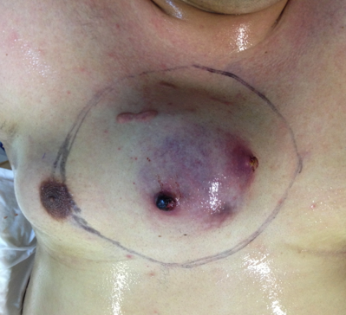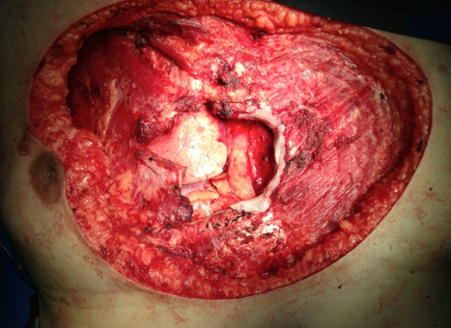
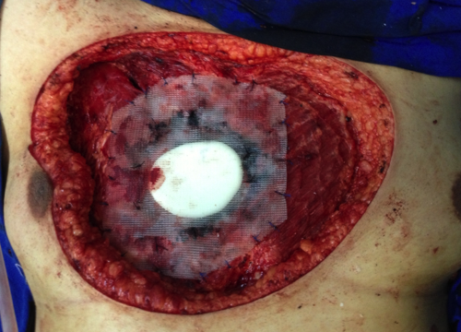

Figure 1. Resection of synovial sarcoma on chest wall with immediately reconstruction using acrylic cement.

DISCUSSION

Primary thoracic wall tumors are a heterogeneous group of neoplasms that originate from bones, soft tissues, or cartilage.⁴ Due to the small number of such lesions and a significant number of these patients being asymptomatic, adequate diagnostic and therapeutic approach is required and other assessments should be considered.^{1,2} In most cancer centers, staging is performed with chest tomography using contrast against lesions close to vessels and magnetic resonance imaging may complement the study of mediastinal lesions and extensive involvement of soft tissues.⁷
Malignant tumors of the thoracic wall occur at a later age, around the age of 60 years old; clinically the lesions are more extensive when compared to the benign ones. The studied population had a mean age of 39.8 and a median of 42.5 (minimum of 4 and maximum of 76 years).
Approximately 50-80% of thoracic wall tumors are malignant. Among the most common benign lesions are ostechondromas, chondromas, fibrous dysplasia, and desmoid tumor. On the other hand, the most common malignancies include sarcomas, chondrosarcomas and Ewing's tumor.^{1,3,5,7} In our study we showed Schwannoma, lipoma and fibrotic dysplasia as benign tumors more frequent. As immature teratoma, osteosarcoma and adenocarcinoma were the most frequent malignant tumors.
Most of the chest wall tumors require extensive resection for their appropriate treatment. It consists in block removal of the lesion including skin, soft parts, rib and sternum, lung, pericardium and diaphragm if they are involved with a wide margin of 4-5 cm. ^{1,2,3,8,11,12,13,14}
Usually, resections are indicated when there is a chance of cure for the patient. Primary thoracic wall tumors account for less than 30% of resection indications, most of which are associated with direct invasion of the chest wall by lung or breast cancer. Rare are the times in which resection is indicated for palliative control, usually when associated with the presence of infection, ulcerated lesion or pain control. ^{1,2,3,8,11,12,13,14}
Radical resection with complete elimination of the disease associated with the advancement of reconstruction techniques, including myocutaneous flaps and / or synthetic mesh, allowed an increase in survival time.⁹ In our study, this method was used in 42% of the cases, associated with reconstruction with synthetic material (polytetrafluroethylene and / or methyl methacrylate). Usually the lesions are of significant size, requiring alternatives for the correction of the chest wall after resection. The priority is restoration of structural and functional integrity of the chest. Reconstruction after resection is necessary to prevent respiratory deficits (paradoxical movement) and for mechanical protection of mediastinal structures. In this sense, work has been done to find ways of approach that combine a better chance of cure of the disease and a satisfactory quality of life for patients.^{1,2,11,13}

DISCLOSURES

The authors indicated no financial relantionships

REFERENCES
1. Shah AA, D’Amico TA. Primary Chest Wall Tumors. J Am Coll Surg [Internet]. Elsevier Inc.; 2010;210(3):360–6. Available from http://linkinghub.elsevier.com/retrieve/pii/S1072751509016123
2. Hsu P-K, Lee H-C, Hsieh C-C, Wu Y-C, Wang L-S, Huang B-S, et al. Management of Primary Chest Wall Tumors: 14 Years’ Clinical Experience. J Chinese Med Assoc [Internet]. Elsevier; 2006;69(8):377–82. Available at: http://dx.doi.org/10.1016/S1726-4901(09)70276-X
3. D’Alessandro P, Carey-Smith R, Wood D. Large resection and reconstruction of primary parietal thoracic sarcoma: A multidisciplinary approach on 11 patients at minimum 2-years follow-up. Orthop Traumatol Surg Res [Internet]. Elsevier Masson SAS; 2011;97(1):73–8. Available at: http://dx.doi.org/10.1016/j.otsr.2010.09.014
4. Leuzzi G, Nachira D, Cesario A, Novellis P, Ciavarella LP, Lococo F, et al. Chest wall tumors and prosthetic reconstruction: A comparative analysis on functional outcome. Thorac Cancer. 2015;6(3):247–54.

5. Bagheri R, Haghi SZ, Kalantari MR, Attar AS, Salehi M, Tabari A, et al. Primary malignant chest wall tumors: analysis of 40 patients. J Cardiothorac Surg [Internet]. 2014;9(1):106. Available at: http://www.cardiothoracicsurgery.org/content/9/1/106
6. Ferraro P, Cugno S, Liberman M, Danino MA, Harris PG. Principles of chest wall resection and reconstruction. Thorac Surg Clin [Internet]. Elsevier Ltd; 2010;20(4):465–73. Available at: http://dx.doi.org/10.1016/j.thorsurg.2010.07.008
7. Koenigkam-Santos M, Sommer G, Puderbach M, Safi S, Schnabel PA, Kauczor H-U, et al. Primary intrathoracic malignant mesenchymal tumours: computed tomography features of a rare group of chest neoplasms. Insights Imaging [Internet]. 2014;5:237–44. Available at: http://www.pubmedcentral.nih.gov/articlerender.fcgi?artid=3999366&tool=pmcentrez&rendertype=abstract
8. Kucharczuk JC. Chest Wall Sarcomas and Induction Therapy. Thorac Surg Clin [Internet]. Elsevier Inc; 2012;22(1):77–81. Available at: http://dx.doi.org/10.1016/j.thorsurg.2011.08.015
9. Yang H, Tantai J, Zhao H. Clinical experience with titanium mesh in reconstruction of massive chest wall defects following oncological resection. J Thorac Dis. 2015;7(7):1227–34.
10. A reconstructive algorithm for plastic surgery following extensive chest wall resection Losken A., Thourani V.H., Carlson G.W., Jones G.E., Culbertson J.H., Miller J.I., Mansour K.A. (2004) British Journal of Plastic Surgery, 57 (4) , pp. 295-302.
11. Van Geel AN, Wouters MWJM, Lans TE, Schmitz PIM, Verhoef C. Chest wall resection for adult soft tissue sarcomas and chondrosarcomas: Analysis of prognostic factors. World J Surg. 2011;35:63–9.
12. Kachroo P, Pak PS, Sandha HS, Lee C, Elashoff D, Nelson SD, et al. Single-Institution, Multidisciplinary Experience with Surgical Resection of Primary Chest Wall Sarcomas. J Thorac Oncol. 2012;7(3):552–8.
13. Wouters MW, Van Geel AN, Nieuwenhuis L, Van Tinteren H, Verhoef C, Van Coevorden F, et al. Outcome after surgical resections of recurrent chest wall sarcomas. J Clin Oncol. 2008;26(31):5113–8.
14. McMillan RR, Sima CS, Moraco NH, Rusch VW, Huang J. Recurrence patterns after resection of soft tissue sarcomas of the chest wall. Ann Thorac Surg [Internet]. Elsevier Inc; 2013;96(4):1223–8. Available at: http://dx.doi.org/10.1016/j.athoracsur.2013.05.015

