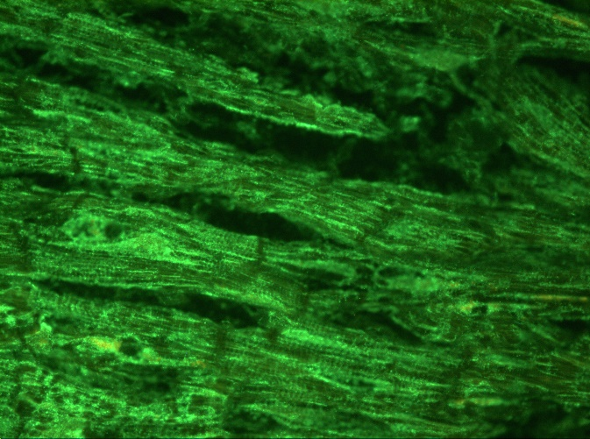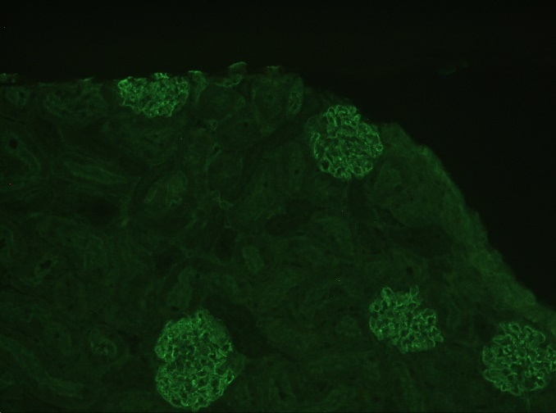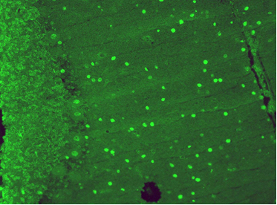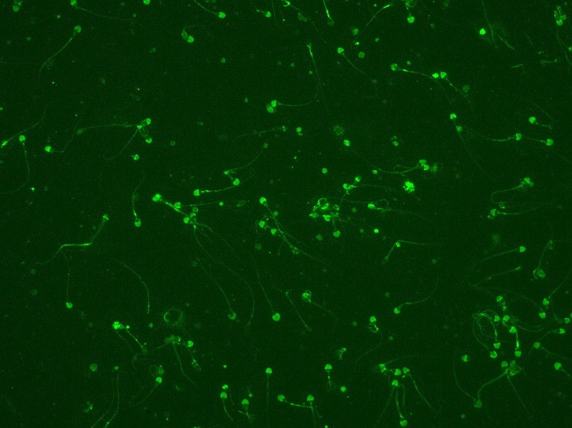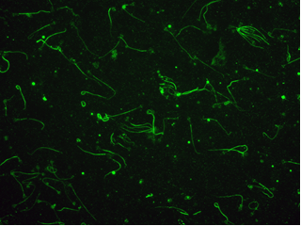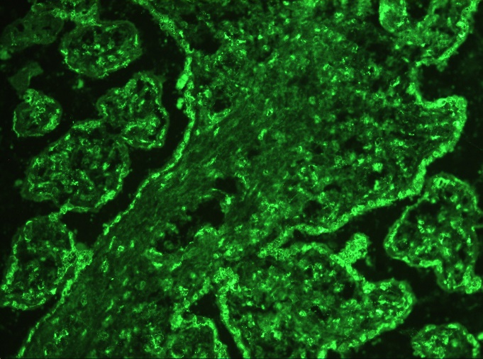
F
E
C
D
B
A
Fig.4. A. Longitudinal section from primate heart muscle showing positive cross-striations; B. renal cortex revealing positive glomerular basement membranes (GBM antibody); C. The cerebellar cortex showing positive nuclei of Purkyně cells as well as of neurons within the granular layer (the molecular layer is negative). D and E: positive staining of sperm cells; low grade or negative staining of tails, strongly positive heads at the acrosome area (in D); positive tails along with positive head membranes (showing loop-like appearance, in E). F: section from placenta showing the villi covered by positively stained syncytiumtrophoblast (anti-SCT antibodies).

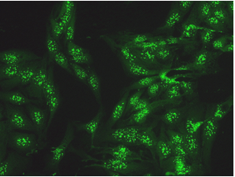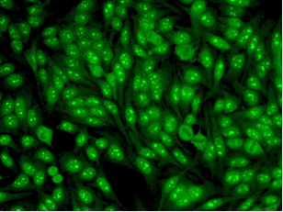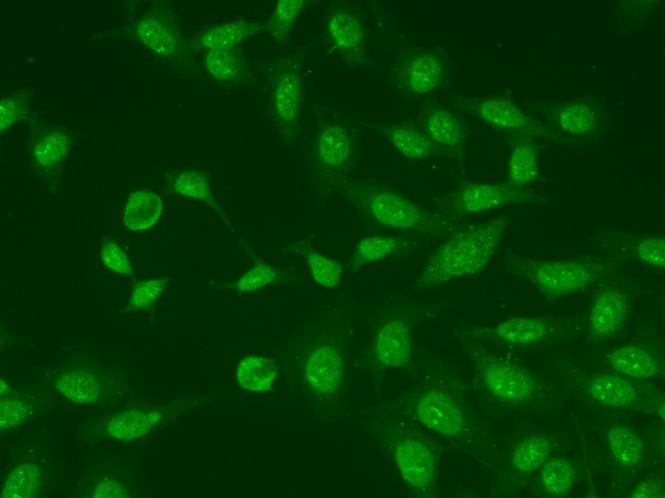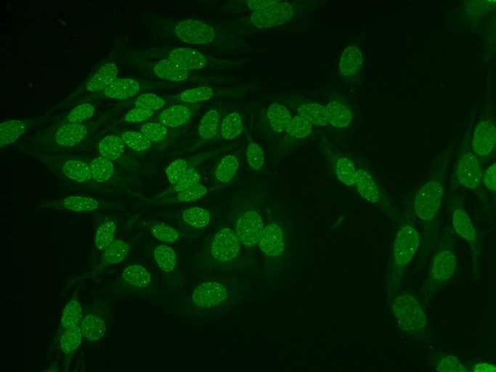
D
C
B
A
Fig. 2. Less frequent and/or rare nuclear patterns. A. Multiple nuclear dots, cetromere pattern (IB: CENP-B positive, SS-A slightly positive). B. Homogenous nucleolar (IB: PM-Scl positive). C. Fine grainy nuclear, Scl-like (IB: Scl-70 positive). D. Few nuclear dots (IB: the Euroline ANA profile 3 negative; putative antigen is coilin, Adrande et al. 1991).
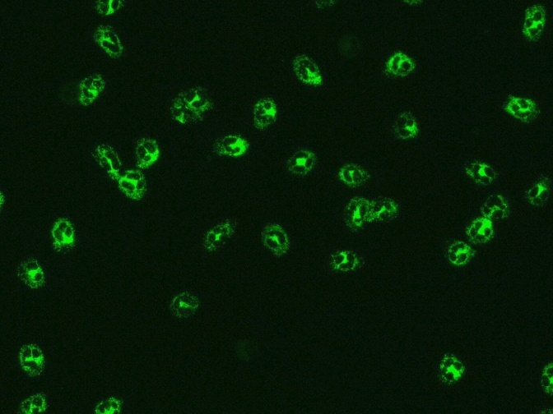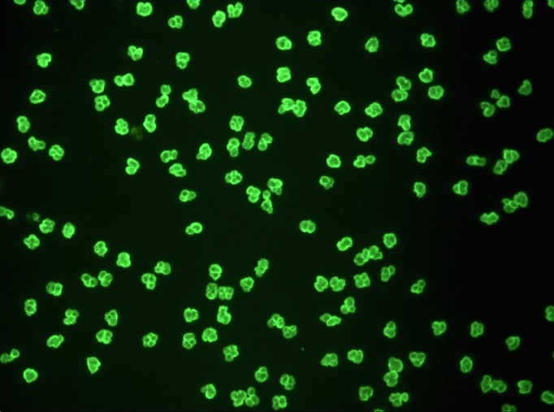
B
A
Fig. 3. The two basic ANCA patterns. 3A. Example of cANCA, etanol fixation, cytplasmic granules, PR3 positive. 3B. Example of pANCA, nuclear membrane accented with strictly perinuclear localization of granules, MPO positive.

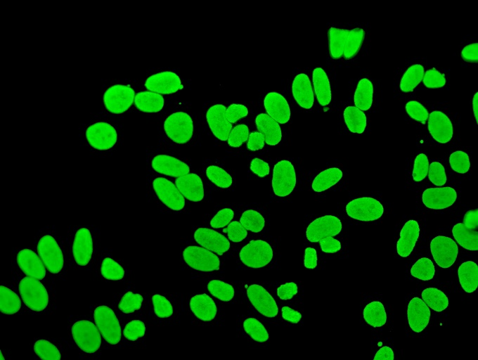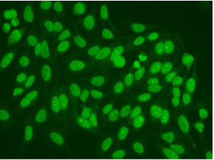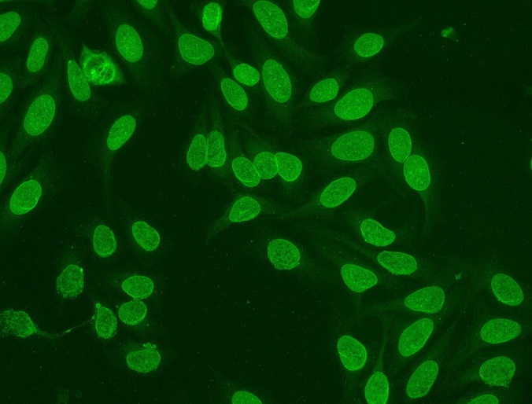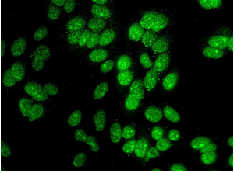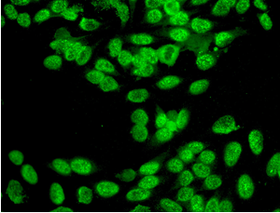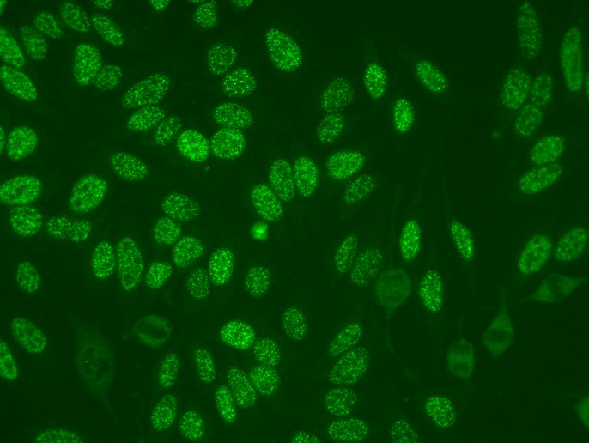
C
B

E
F
D
A

Fig.1. The frequent ANA patterns as seen by IFA technique: A. Homogenous nuclear, no nucleoli seen (IB: antibodies to dsDNA, nucleosomes and to Jo-1 protein were positive, antibodies to PM-Scl slightly positive); B. Homogenous nuclear with accented nucleoli (IB: SS-A, SS-B, Ro-52, nucleosomes, ds-DNA and AMA-M2 positive); C. Nuclear rim positive (IB : negative, i.e. no antibodies found in the Euroline ANA Profile 3 strip); D. Coarse speckled nuclear staining with positive nuceloli (IB: SS-A, SS-B and Ro-52 positive); E. Fine speckled nuclear (IB: SS-A, SS-B, Ro-52, ds-DNA and nucleosomes positive, histones slightly positive); F. Large speckled nuclear fluorescence (IB: U1-nRNP/Sm antigen positive).

